How To Minimize DFA?

The two popular methods for minimizing a DFA are-

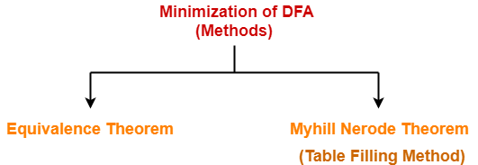

In this article, we will discuss Minimization of DFA Using Equivalence Theorem.

Minimization of DFA Using Equivalence Theorem-

Step-01:

Eliminate all the dead states and inaccessible states from the given DFA (if any).

Dead State

All those non-final states which transit to itself for all input symbols in ∑ are called as dead states.

Inaccessible State

All those states which can never be reached from the initial state are called as inaccessible states.

Step-02:

- Draw a state transition table for the given DFA.
- Transition table shows the transition of all states on all input symbols in Σ.

Step-03:

Now, start applying equivalence theorem.
- Take a counter variable k and initialize it with value 0.
- Divide Q (set of states) into two sets such that one set contains all the non-final states and other set contains all the final states.
- This partition is called P₀.

Step-04:

- Increment k by 1.
- Find P_{k} by partitioning the different sets of P_{k-1} .
- In each set of P_{k-1} , consider all the possible pair of states within each set and if the two states are distinguishable, partition the set into different sets in P_{k}.

Two states q₁ and q₂ are distinguishable in partition P_{k} for any input symbol ‘a’,
if δ (q₁, a) and δ (q₂, a) are in different sets in partition P_{k-1}.

Step-05:

- Repeat step-04 until no change in partition occurs.
- In other words, when you find P_{k} = P_{k-1}, stop.

Step-06:

- All those states which belong to the same set are equivalent.
- The equivalent states are merged to form a single state in the minimal DFA.

Number of states in Minimal DFA
= Number of sets in P_{k}

PRACTICE PROBLEMS BASED ON MINIMIZATION OF DFA-

Problem-01:

Minimize the given DFA-

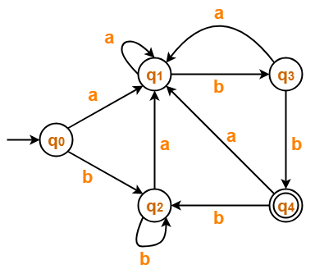

Solution-

Step-01:

The given DFA contains no dead states and inaccessible states.

Step-02:

Draw a state transition table-

 | a | b
→q0 | q1 | q2
q1 | q1 | q3
q2 | q1 | q2
q3 | q1 | *q4
*q4 | q1 | q2

Step-03:

Now using Equivalence Theorem, we have-
P₀ = { q₀ , q₁ , q₂ , q₃ } { q₄ }
P₁ = { q₀ , q₁ , q₂ } { q₃ } { q₄ }
P₂ = { q₀ , q₂ } { q₁ } { q₃ } { q₄ }
P₃ = { q₀ , q₂ } { q₁ } { q₃ } { q₄ }

Since P₃ = P₂, so we stop.
From P₃, we infer that states q₀ and q₂ are equivalent and can be merged together.
So, Our minimal DFA is-

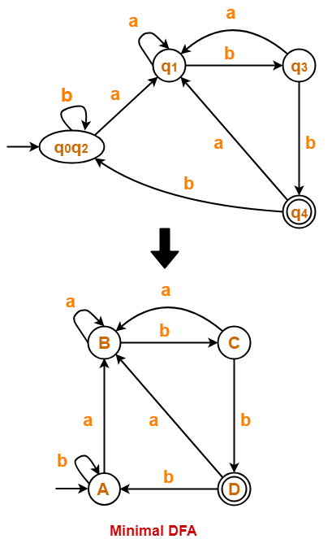

Problem-02:

Minimize the given DFA-

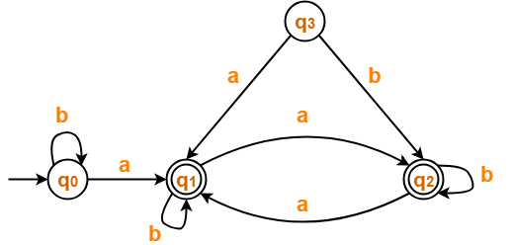

Solution-

Step-01:

- State q₃ is inaccessible from the initial state.
- So, we eliminate it and its associated edges from the DFA.

The resulting DFA is-

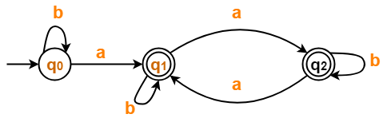

Step-02:

Draw a state transition table-

 | a | b
→q0 | *q1 | q0
*q1 | *q2 | *q1
*q2 | *q1 | *q2

Step-03:

Now using Equivalence Theorem, we have-
P₀ = { q₀ } { q₁ , q₂ }
P₁ = { q₀ } { q₁ , q₂ }

Since P₁ = P₀, so we stop.
From P₁, we infer that states q₁ and q₂ are equivalent and can be merged together.
So, Our minimal DFA is-

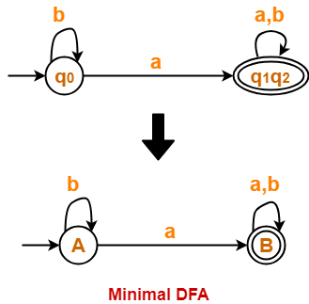

Problem-03:

Minimize the given DFA-

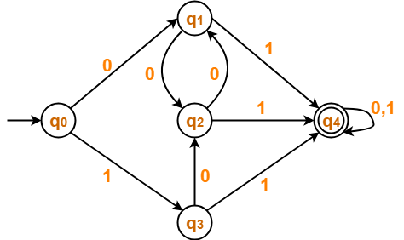

Solution-

Step-01:

The given DFA contains no dead states and inaccessible states.

Step-02:

Draw a state transition table-

 | 0 | 1
→q0 | q1 | q3
q1 | q2 | *q4
q2 | q1 | *q4
q3 | q2 | *q4
*q4 | *q4 | *q4

Step-03:

Now using Equivalence Theorem, we have-
P₀ = { q₀ , q₁ , q₂ , q₃ } { q₄ }
P₁ = { q₀ } { q₁ , q₂ , q₃ } { q₄ }
P₂ = { q₀ } { q₁ , q₂ , q₃ } { q₄ }

Since P₂ = P₁, so we stop.
From P₂, we infer that states q₁ , q₂ and q₃ are equivalent and can be merged together.
So, Our minimal DFA is-

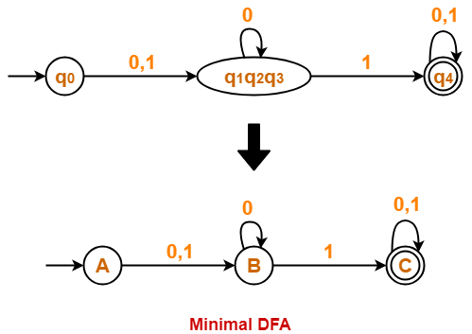

Problem-04:

Minimize the given DFA-

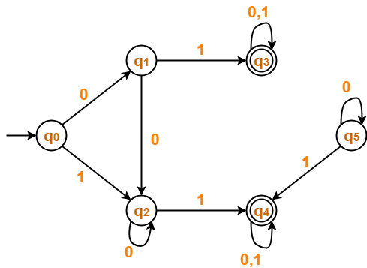

Solution-

Step-01:

- State q₅ is inaccessible from the initial state.
- So, we eliminate it and its associated edges from the DFA.

The resulting DFA is-

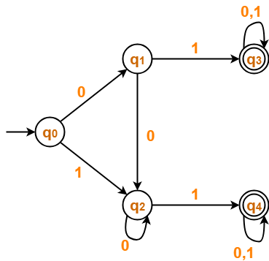

Step-02:

Draw a state transition table-

 | 0 | 1
→q0 | q1 | q2
q1 | q2 | *q3
q2 | q2 | *q4
*q3 | *q3 | *q3
*q4 | *q4 | *q4

Step-03:

Now using Equivalence Theorem, we have-
P₀ = { q₀ , q₁ , q₂ } { q₃ , q₄ }
P₁ = { q₀ } { q₁ , q₂ } { q₃ , q₄ }
P₂ = { q₀ } { q₁ , q₂ } { q₃ , q₄ }

Since P₂ = P₁, so we stop.
From P₂, we infer-
- States q₁ and q₂ are equivalent and can be merged together.
- States q₃ and q₄ are equivalent and can be merged together.
So, Our minimal DFA is-

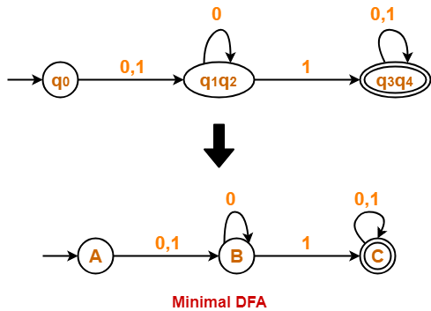

Also Read- Construction of DFA

To gain better understanding about Minimization of DFA,
Watch this Video Lecture

Next Article- Converting DFA to Regular Expression

